**Assignment 3- Implementation of Random Forest**

I ran the project for different number of trees as input. Initially there was

an error rate of around 39%. Later I tried with increasing the number of trees till 100. There was slight increase in the accuracy level of the random forest. Below are the tables showing the % of accuracy and the % of Error rate with respect to the number of trees as input to the random forest. Finally I ran with 100 as the number of trees with the error rate of 32%.

|  |  |
| --- | --- |
| Number of trees in the random forest | Accuracy % |
| 1 | 61 |
| 5 | 66 |
| 10 | 67 |
| 15 | 62 |
| 20 | 63 |
| 30 | 65 |
| 38 | 68 |
| 45 | 68 |
| 100 | 68 |

|  |  |
| --- | --- |
| Number of trees in the random forest | Error % |
| 1 | 39 |
| 5 | 34 |
| 10 | 33 |
| 15 | 38 |
| 20 | 37 |
| 30 | 35 |
| 38 | 32 |
| 45 | 32 |
| 100 | 32 |

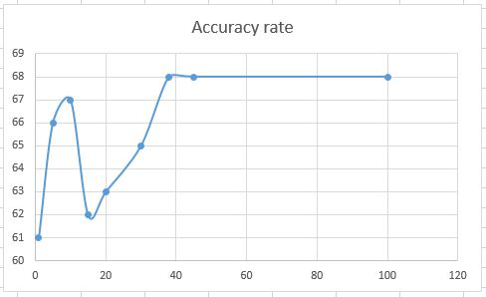

Number of trees

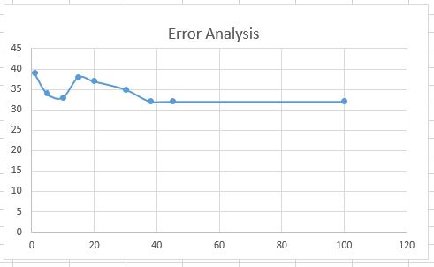

Number of trees